EP Collectable | Subject: Geography | Topic: Amazing Amazon | Year 5
Key Knowledge
- Learn about a region in South America
- Be able to locate the world’s major rivers on a map.
- Be able to locate the worlds tropical rainforests on a map.
- Compare facts about the major rivers of the world and compare to the River Thames. Link this to learning about the water cycle.
- Be able to use a compass - eight points of a compass - and four-point coordinates. Be able to use a compass and map to orienteer.

Being A Geographer
- Using OS and public transport maps to locate places and plan routes
- Using compass directions
- Recognise physical features in maps and aerial photographs
- Using fieldwork and observation

Key Concepts
Location Knowledge | Place Knowledge | Human Geography | Physical Geography
Being able to use a map to locate rivers, concentrating on their country, continent and key characteristics. Notice land-use patterns and how these have changed over time. | Understand geographical features of a river – its source, route and mouth.  Consider the impact this has on the countries surrounding each river. | Consider the lives of people that live in South America, particularly around the Amazon river. Explore how the adaptations that humans make based on their surroundings. | Explore the features of the rainforest, considering the different layers and its inhabitants. Consider the impact of deforestation and the use of the land.
Linking Thinking Across Our Learning Journey
Nursery | Reception | Year 1 | Year 2 | Year 3 | Year 4 | Year 5 | Year 6
Early map work placing school in local area | Exploring the streets beyond school | Map work in ‘Our Local Area’ | Around the World | Locating mountains and volcanoes | Map work for Camping Trip and ‘Survival’ | Amazing Amazon | Understanding land-use and trade in farming

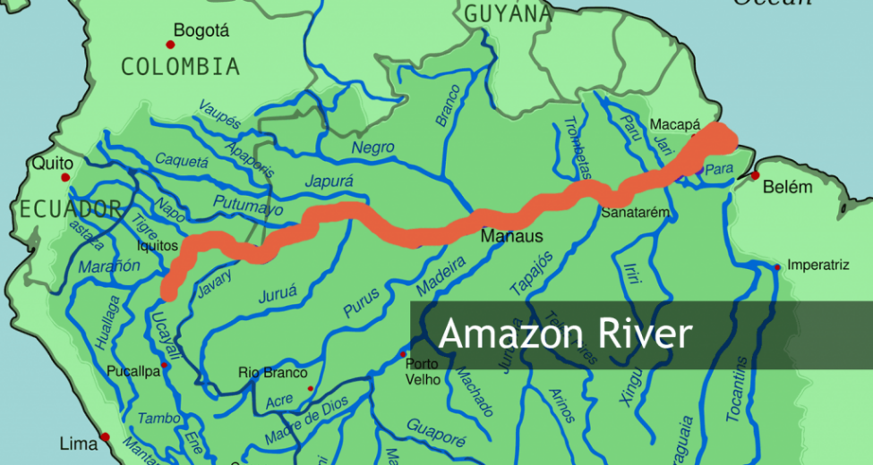
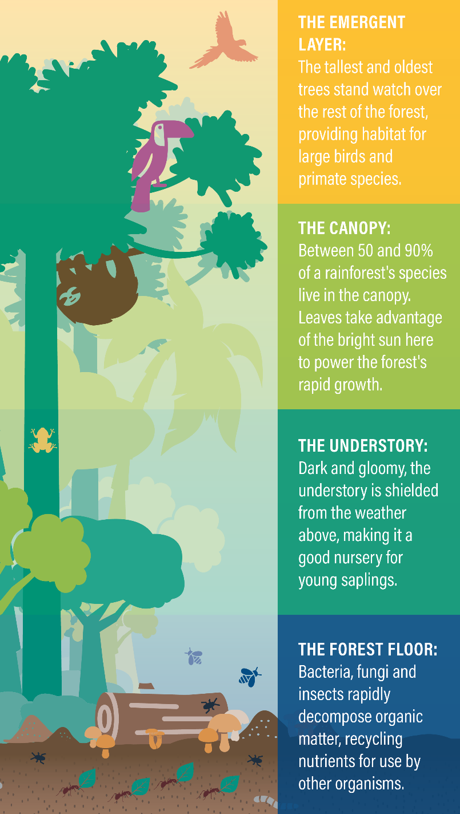
Key Vocabulary:
Biodiversity: the wide variety of things living on earth.
Biome: a community of vegetation and wildlife that has adapted to a specific environment.
Climate: the weather and temperature usually found in an area over a long period of time.
Deforestation: the destruction of trees in a large area.
Habitat: the place where a living thing makes its home.
Humid: a high level of moisture in the air.
Population: the inhabitants of a particular place.
Rainforest: a forest located around the tropics, which is a zone around the equator.
Vegetation: the plant life growing in a certain area.

Rainforest Layers

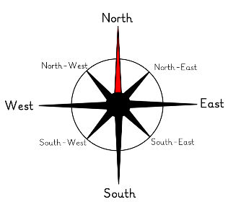
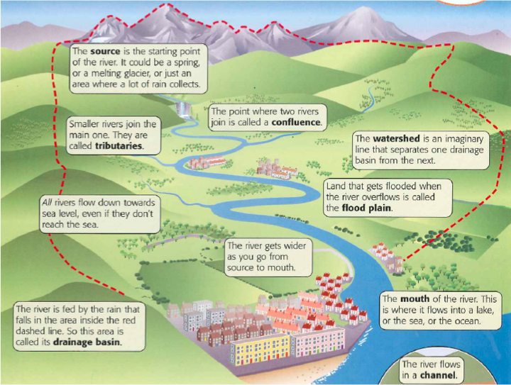
Key Vocabulary:
Banks: the sides of a river that the water normally flows through.
Channel: the path that a river takes over land.
Delta: a large, silty area found at the mouth of a river – often triangular shaped.
Deposition: where material is laid down in another location.
Erosion: the process where material is removed from one area and transported to another.
Estuary: the area where a river meets the ocean or sea.
Floodplain: the flat area next to a river that floods.
Meander: a bend or curve in a river.
Mouth: where a river ends.
Reservoir: a man mad structure that stores water.
River bed: the bottom of a river.
Sediment: a mixture of small particles of soil and rock.
Source: the beginning of a river.
Transportation: where eroded material is moved downstream by the flowing water.
Tributary: this is a smaller river that flows into a main river.
River Source to Mouth

