Event | Description | Dates
Outbreak of WW2 | On 1st September 1939, Germany invaded Poland. Britain and France (Poland’s allies) gave Germany notice to withdraw their troops. When they did not, Neville Chamberlain declared war on 3rd September 1939. | 1st – 3rd September 1939
Evacuation of children | People expected cities to be bombed as the Germans tried to hit military or trade targets. This would put children in danger, so many were sent to live with families in the countryside until the war ended. | September 1939 onwards
The Holocaust | The Holocaust was a genocide committed by Germany before and during WW2. It involved the murder of over 6 million Jewish people and millions of others. Many people perished in concentration camps. | 1933-1945
Evacuation of Dunkirk | Large numbers of British, French and Belgian troops were surrounded by German soldiers on the northern coast of France. 800 British boats set out and rescued many of them against the odds, although many men died. | 26th May – 4th June 1940
Battle of Britain | In the Battle of Britain, the Royal Air Force (RAF) successfully defended Britain from attacks by Nazi Germany’s Luftwaffe planes. | 10th July – 31st October 1940
The Attack on Pearl Harbour | This was a surprise military attack by the Japanese on the naval base at Pearl Harbour in Hawaii. It led to the US joining the Allies in the war. | 7th December 1941
D-Day Landings | Also known as the Normandy Landings, these were a series of landing operations by the Allies to claim back Europe. | 6th June 1944
Hitler’s Suicide | With the German army facing defeat, Hitler married his partner Eva Braun on the 29th April and the next day they committed suicide. | 30th April 1945
Germany Surrenders | Germany officially surrendered to the Allies, bringing an end to the fighting in Europe. | 7th May 1945
USA drops atomic bombs on Japan | Japan refused to surrender. The US considered invading, but instead dropped atomic bombs on Hiroshima (6th August) and Nagasaki (9th August). | 6th-9th August 1945
WW2 Ends | Japan surrendered on August 15th and this was formally signed on the 2nd September 1945. | 2nd September 1945
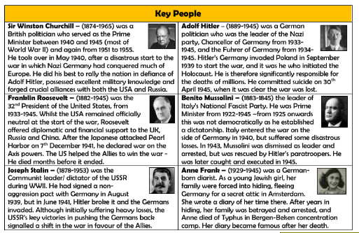
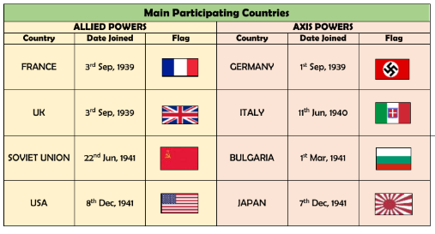
Key Vocabulary
Air-raid | An attack by enemy planes dropping bombs.
Anderson shelter | A small shelter made from corrugated steel to protect people in air-raids.
Allies | Countries (including Britain, France, the Soviet Union and the USA) who fought the Axis Powers.
Atomic bomb | A powerful weapon that uses nuclear reactions as its source of explosive energy. First used in 1945.
Axis Powers | Germany, Japan, Italy and other countries that fought against the Allies.
Blackout | A wartime ban on streetlights and other lights at night, to reduce the risk of bombing by enemy planes.
Blitz | A prolonged period of German air raids on Britain. From the German ‘blitzkrieg’ which means ‘lightning war’.
Concentration camps | Prisons where Jewish people and other prisoners were held by the Nazis.
Evacuation | Moving people from dangerous areas to safer places e.g. from big cities to the countryside to avoid bombing.
Fascism | A political system where the strength of the country is more important than the well-being of the people. Often ruled by dictators with unlimited power through suppression of any opposition and strict control of society.
Führer | German word meaning ‘leader’ or ‘guide’. The title Hitler gave himself in 1934 when he gained absolute authority in Germany.
Gas masks | Face masks to protect people from poisonous gas attacks.
Genocide | Deliberate action to destroy a people (usually defined as an ethnic, national, racial, or religious group).
Holocaust | The mass murder of around six million Jewish people by the Nazis, as well as other persecuted groups.
Invasion | When an army or country uses force to enter and take control of another country or area.
Liberated | Freed from enemy control.
Luftwaffe | The German air force during the war.
Occupied | Taken over by enemy forces.
Nazi | Short for National Socialist Party (in Germany) and the name given to supporters of Hitler.
Persecution | Systematic mistreatment of an individual or group, especially because of race, religion or political beliefs.
Propaganda | Information, especially of a biased or misleading nature, used to promote a political cause or point of view.
Rationing | Controlling the supply of food, clothes, petrol and other products to avoid or reduce shortages.
Spitfire | A British aircraft, particularly used during the Battle of Britain and known for its speed and agility.
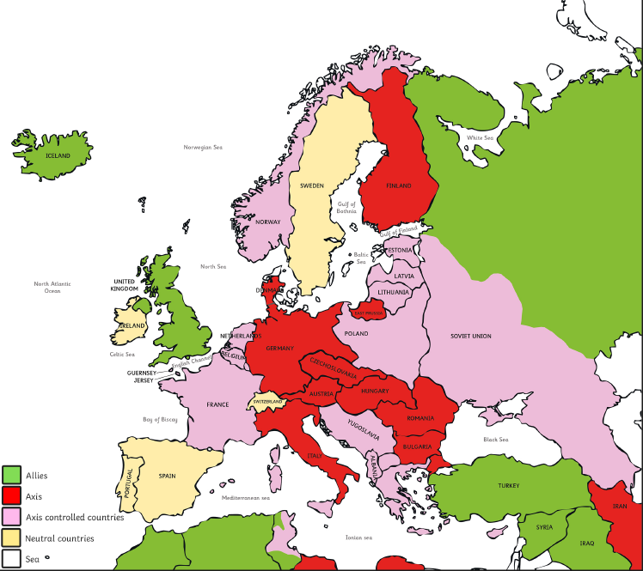
Areas of Control during World War Two – Map of Europe in 1941

